User Manual

/*****************************************************************************
SaveDollars - Open source Android application that helps users to compare prices of a product across different ecommerce sites and make a decision about purchase.
Copyright (C) 2013 Smita Kundargi and Jeanne Betcy Victor

This program is free software: you can redistribute it and/or modify it under the terms of the GNU General Public License as published by the Free Software Foundation, either version 3 of the License, or (at your option) any later version.

This program is distributed in the hope that it will be useful, but WITHOUT ANY WARRANTY; without even the implied warranty of MERCHANTABILITY or FITNESS FOR A PARTICULAR PURPOSE.
See the GNU General Public License for more details.

You should have received a copy of the GNU General Public License along with this program. If not, see http://www.gnu.org/licenses/.

Following is the link for the repository: https://github.com/SmitaBetcy/SaveDollars

Author - Smita Kundargi and Jeanne Betcy Victor
email: ksmita@pdx.edu and jbv3@pdx.edu

****************************************************************************/

Using SaveDollars Application.

This application allows you to compare price of a product for different merchants.

Users can fetch the product details (I.e Product Price, Shipping and Availability of the product) by scanning the barcode of the product or by entering the barcode in the text field.

The main screen:
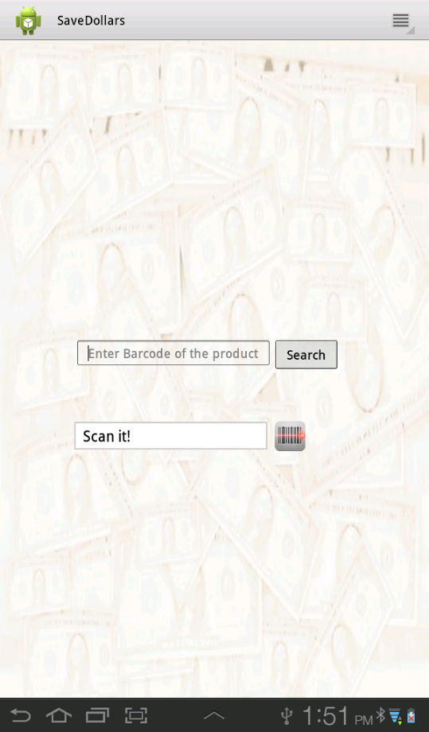

Enter the barcode of the product in Text field and click on search:

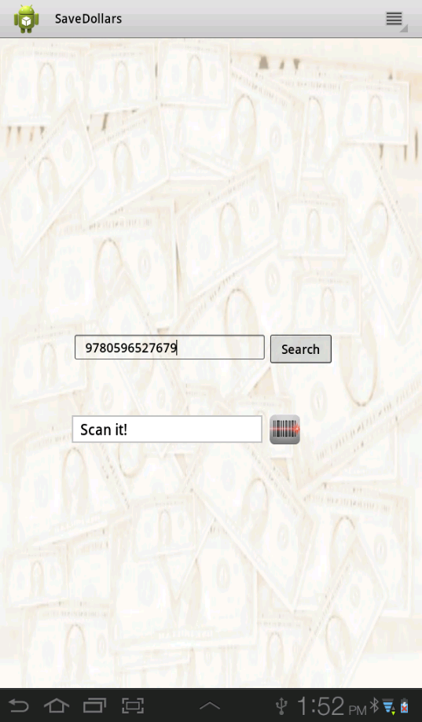

OR
Directly click on the scan button and scan the barcode. [ Once you click on the scan button,
you will see a green line. Place the green line on the barcode, and your barcode
will be scanned correctly.]

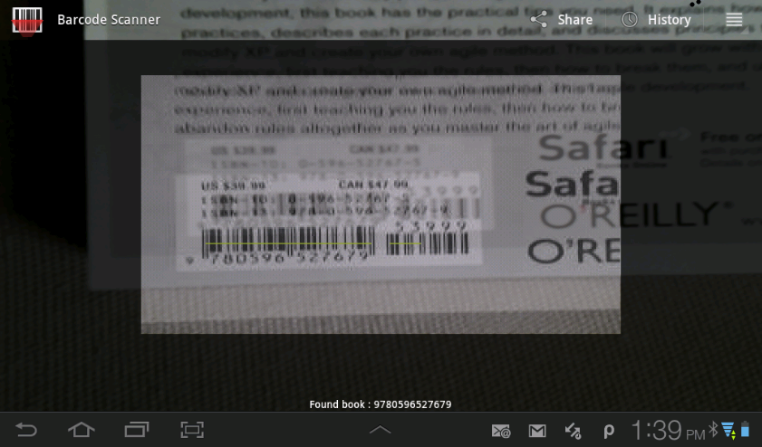
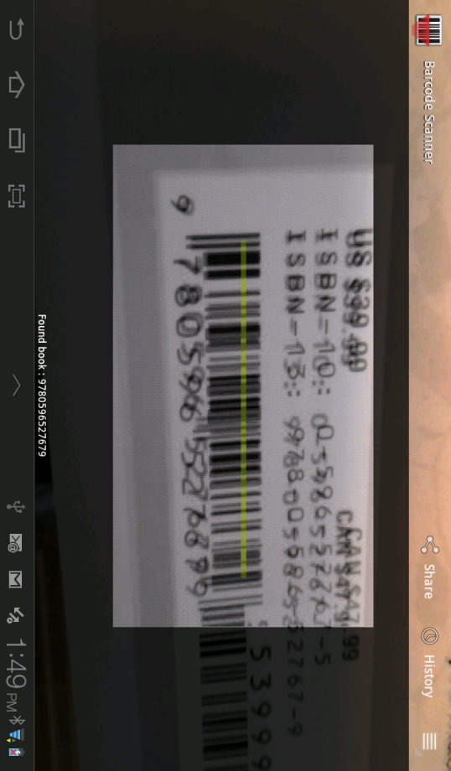

The user will now be directed to the “Total Screen”

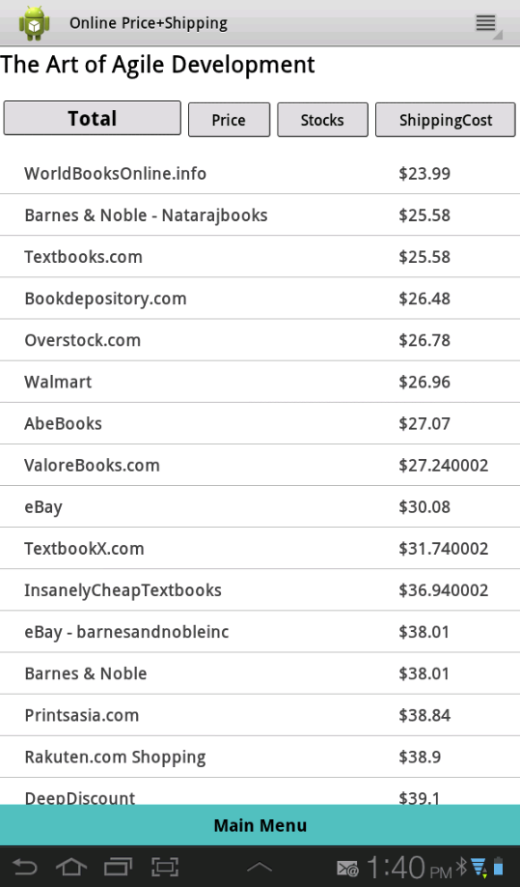

This displays all the merchants of the product and the total price, in sorted order of total price. Total price is the sum total of Product price plus the shipping price.

To check the Product price click on the “Price” Button

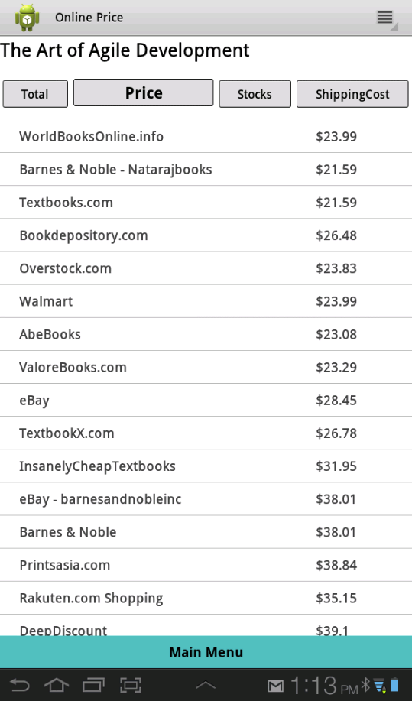
This displays the merchants of the product along with the Product price.

Click on the Shipping Button to get the shipping cost of the product.
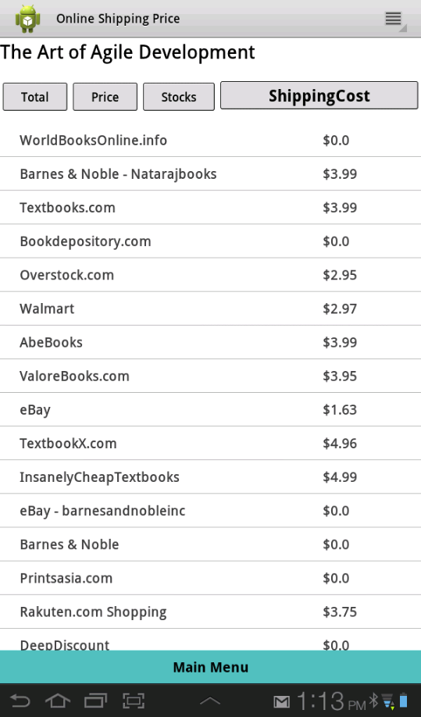
This displays the merchants of the product along with the Shipping price.

Click on the Stocks Button to get the availability of the product. This displays the merchants of the product along with their Availability.

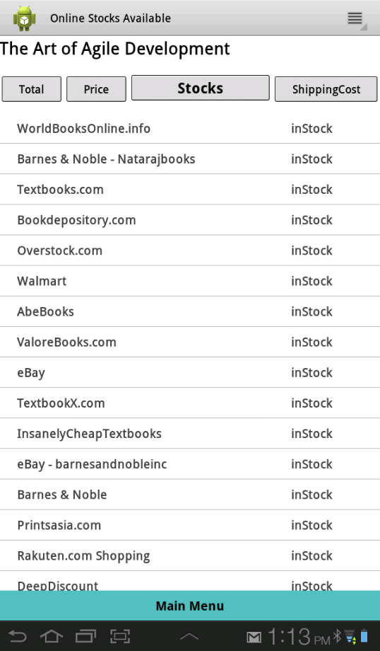

You can click on the merchant name to go to their home page:

Example: Merchant : Walmart.

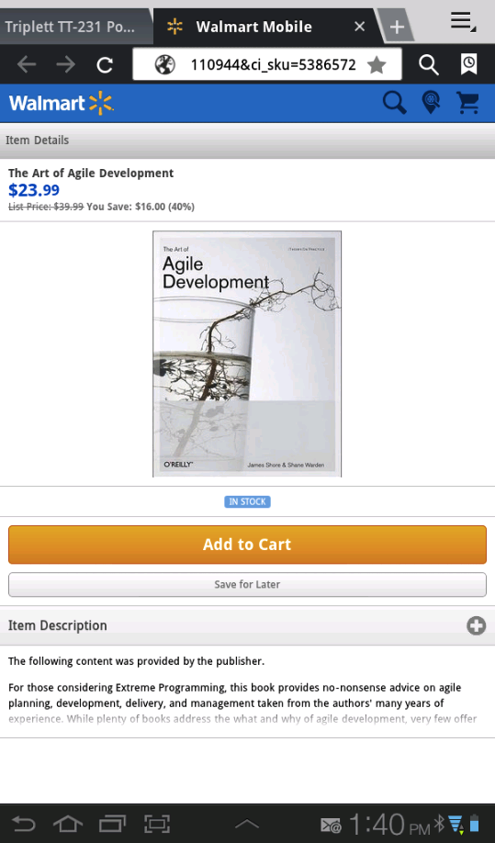

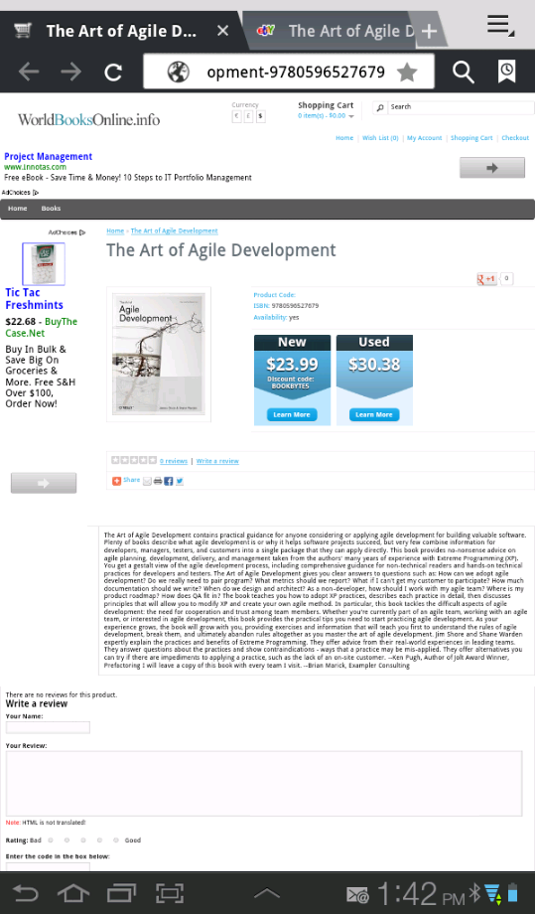

Example: Merchant: WorldBooksOnline.info

If the product information is not found you will get the following screen.

